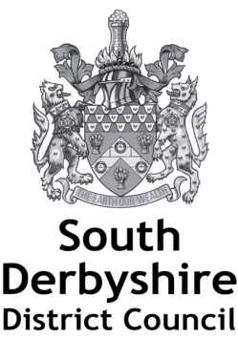

The Animal Welfare (Licensing of Activities Involving Animals) Regulations 2018

Variation Application Form

Please complete all the questions on the form.

Please note that a full inspection will be carried out on receipt of this application. Re-inspection for re-rating purposes could lead to a lower rating being awarded rather than an increase in rating.

Applicant details
Name
Address

Email
Telephone number
Mobile number

Address of Licensed Premises (if different from above)
Licence Holder Name
Premises Name
Street
Town
County
Postcode

Licensed Premises
Type of activity premises is licensed for

Nature of Variation
Please provide details of the proposed variation. Please include any evidence in support of your request. Please continue on a separate sheet if required.

Declaration

Payment
Payment must be made at the time of making the application:
I enclose the application fee of £147 | ☐
I have paid the application fee over the telephone | ☐

Declaration
The applicant must complete this section.
If you are an agent, please ensure the applicant completes this section.
I am aware of the provisions of the relevant Act and model licence conditions. I confirm I have read the model conditions and guidance (which can be found at https://www.south-derbys.gov.uk/our-services/licensing/animal-licences/animal-welfare-regulations-2018)
The details contained in the application form and any attached documentation are correct to the best of my knowledge and belief.
Signed
Full name
Position
Date

Privacy notice
How is your information used?
We collect information to assess your suitability to be issued with a licence. We may also use your contact details in the event that we need to contact you in relation to your licence.
Who has access to your information?

Information is shared with other regulatory and enforcement authorities including, but not limited to, other Council services; Councillors; the Police; the Fire Authority; Trading Standards; HM Revenues and Custom; veterinary surgeons, and other local authorities when allowed to by law for the purposes of the administration and enforcement of authorisations, and for the purposes of the prevention and detection of crime, public safety, public health, protection of the environment and prevention of fraud.

Certain information about licences (including in particular your name and the address of any premises to which a licence applies) may be published on a public register on our website when we are required to by law. Licences that have to be determined by our Councillors will be published in minutes on our website.

For further information about your personal information will be used, please visit www.south-derbys.gov.uk where you can see a full copy of our privacy notice. Alternatively you can request a hard copy from licensing@south-derbys.gov.uk

