SOUTH DERBYSHIRE DISTRICT COUNCIL POLLING DISTRICT AND POLLING PLACE REVIEW 2024
Returning Officer’s Recommendations as approved at Council on 16 January 2024

Ward | Area | Current  Polling District | (Acting) Returning Officer's Recommendations | Current Polling station no | Current Polling Station Location | (Acting) Returning Officer's Recommendations
Aston | Aston-on-Trent | ASA | No Change | 1 | Memorial Hall, Chellaston Lane, Aston on Trent, DE72 2AX | No Change
 | Stenson Fields (East) | ASB1 | Rename ASB1 to ASB. | 2 | St Wilfrids Church, Church Lane, Barrow on Trent, DE73 7HB | No Change
 | Barrow-on-Trent | ASB2 | Rename ASB2 to ASH. | 2 | St Wilfrids Church, Church Lane, Barrow on Trent, DE73 7HB | No Change
 | Elvaston | ASC | Adjust ASC/ASD boundaries to even up electorate at relevant Polling Places. See Fig.1 below. | 3 | Elvaston Village Hall, Off Main Street, Elvaston, DE72 3EP | No Change
 | Boulton Moor / Elvaston | ASD | Adjust ASC/ASD boundaries to even up electorate at relevant Polling Places. See Fig.1 below. | 4 | Mobile Unit, Colwell Drive, Boulton Moor, DE24 0UP | To continue with the current Polling Place until alternatives are available.
 | Shardlow | ASE | No Change | 5 | Shardlow Village Hall, The Wharf, DE72 2GH | No Change
 | Swarkestone | ASF | No Change | 6 | Swarkestone Cricket Club Pavilion, Barrow Lane, DE73 7JA | No Change
 | Weston-on-Trent | ASG | No Change | 7 | Weston-on-Trent Village Hall, Main Street, DE72 2BL | No Change
Figure 1- Boundary of Polling District ASD, the area shaded orange, to extend to include the area shaded Yellow, currently part of Polling District ASC.
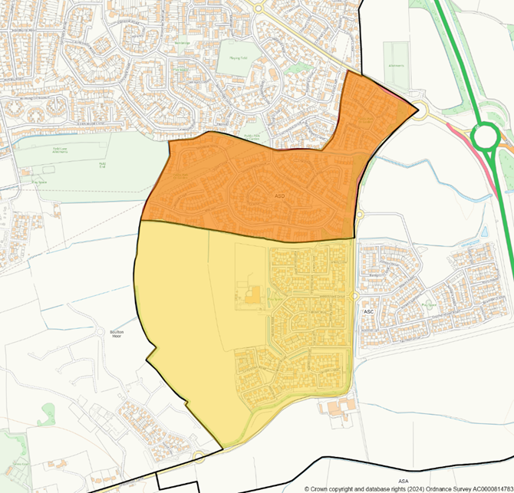

Church Gresley | Church Gresley | CGA | No Change | 8 | Church Gresley Methodist Church, York Road, DE11 9QQ | No Change
 | Church Gresley | CGB | Adjust CGB/CGD boundaries to redistribute electorate (Fig.2). This will not affect Parish, District Ward or County Division boundaries. | 9 | Community Room, Newlands Close, Church Gresley, DE11 9QX | No Change
 | Church Gresley | CGC | No Change | 10 | St George & St. Mary`s Parish Church Room, Church Street, Church Gresley, DE11 9NR | No Change
 | Church Gresley | CGD | Adjust CGB/CGD boundaries to redistribute electorate (Fig.2). This will not affect Parish, District Ward or County Division boundaries. | 11 | Mobile Unit, Gresleydale Healthcare Centre, Glamorgan Way, Church Gresley, DE11 9GB | To seek alternative Polling Place.

Figure 2 - Polling District CGB, shaded yellow, to extend to include the area shaded orange, currently part of CGD
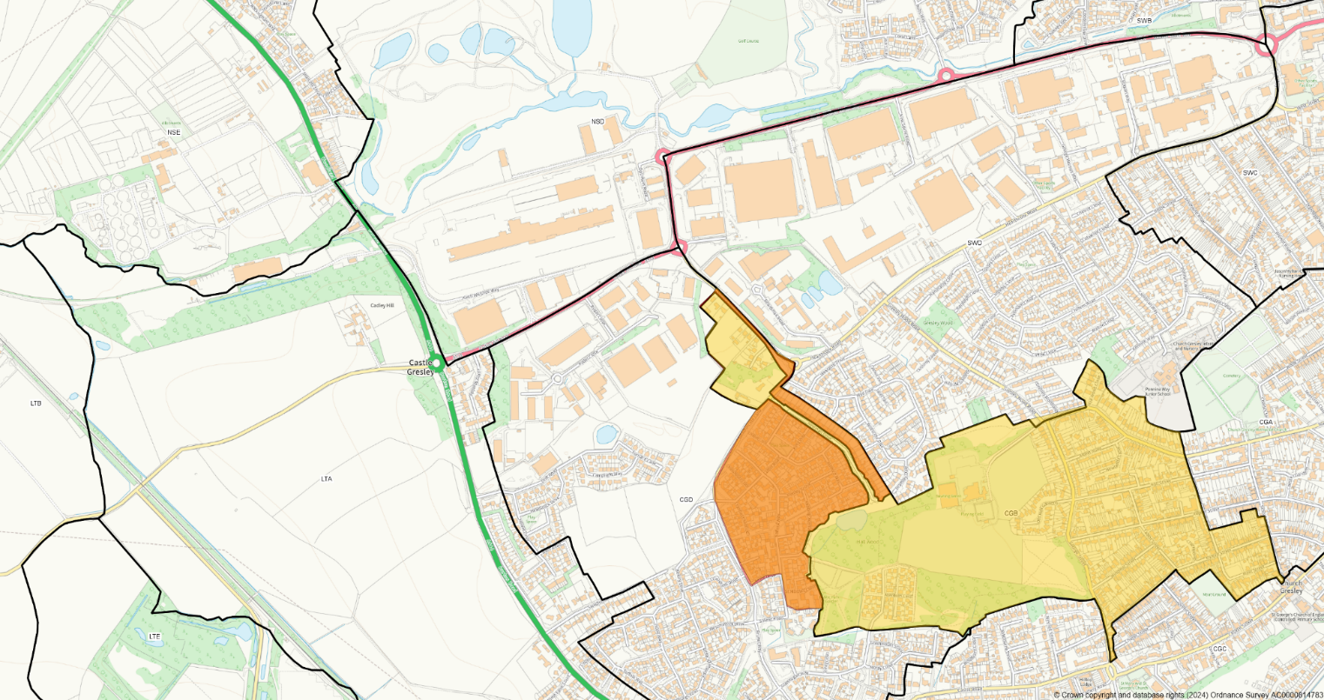

Etwall | Ash | ETA | No Change | 12 | Frank Wickham Hall, Portland Street, Etwall, DE65 6JF | No Change
 | Bearwardcote | ETB | No Change | 12 | Frank Wickham Hall, Portland Street, Etwall, DE65 6JF | No Change
 | Burnaston | ETC | Merge ETC/ETD Polling Districts with the consolidated Polling District to be called ETC (Fig.3) | 13 | Burnaston Village Hall, Main Street, Burnaston, DE65 6LG | Polling place deleted and Electors who previously voted at Polling Station 13 to vote at Mickleover Country Park Social Club (polling station 14)
 | Burnaston (Merlin Way area) | ETD | Merge ETC/ETD Polling Districts with the consolidated Polling District to be called ETC (Fig.3)  Delete the Polling District | 14 | Mickleover Country Park Social Club, Off Merlin Way, DE3 0UJ | To be the Polling Place for the expanded ETC Polling District.
 | Dalbury Lees | ETE | No Change | 15 | Dalbury Lees Village Hall, Dalbury Lees, DE6 5BE | No Change
 | Eggington | ETF | No Change | 16 | Egginton Memorial Hall, Church Road, DE65 6HP | No Change
 | Etwall | ETG | No Change | 12 | Frank Wickham Hall, Portland Street, Etwall, DE65 6JF | No Change
 |  |  |  | 17 | Frank Wickham Hall, Portland Street, Etwall, DE65 6JF | No change - as issue is resolved by revision to where ETI electors vote.
 | Osleston & Thurvaston | ETH | No Change | 15 | Dalbury Lees Village Hall, Dalbury Lees, DE6 5BE | No Change
 | Radbourne | ETI | Split ETI into 2 Polling Districts (Fig.4). Northern section to vote at Dalbury Lees Village Hall (ETI). Southern section to vote at Mickleover Country Park Social Club, until alternative Community Centre in Radbourne is available.  New Polling District to be titled (ETD). | 17 | Frank Wickham Hall, Portland Street, Etwall, DE65 6JF | Polling Place for the reduced Polling District ETI to transfer form Frank Wickham Hall to Dalbury Lees Village Hall.  The newly created ETD Polling District to vote at Mickleover Country Park Social Club Polling Place, until alternative Community Centre in Radbourne is available.
 | Trusley | ETJ | No Change | 15 | Dalbury Lees Village Hall, Dalbury Lees, DE6 5BE | No Change

Figure 3 -Polling District ETD, the area shaded orange, to merge with Polling District ETC, the area shaded yellow, to create a new combined Polling District titled ETC.
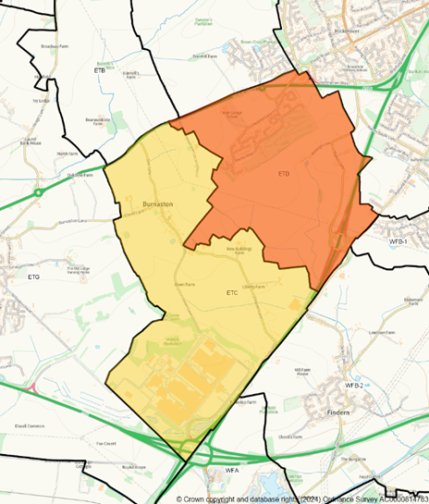

Figure 4 - Polling District ETI to be divided into two distinct Polling Districts, the northern area, shaded yellow, will be retained as Polling District ETI and the southern area, shaded orange to be a new Polling District titled ETD

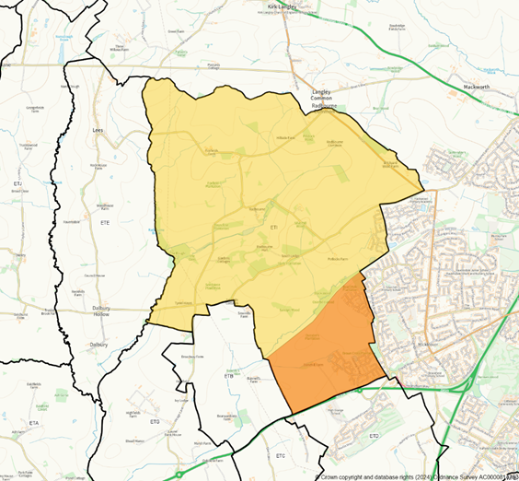

Hilton | Barton Blount | HLA | No Change | 20 | St Michaels Church, Church Road, Church Broughton, DE65 5BB | Move Polling Station to Church Broughton  Community Hall
 | Church Broughton | HLB | No Change | 20 | St Michaels Church, Church Road, Church Broughton, DE65 5BB | Move Polling Station to Church Broughton Community Hall.
 | Foston & Scropton | HLC | No Change | 21 | Foston & Scropton Parish Hall, Scropton Road, Scropton, DE65 5PS | No Change
 | Hatton | HLD | No Change | 22 | Hatton Jubilee Hall, Station Road, DE65 5EL | No Change
 | Hilton | HLE | No Change | 23 | Hilton Village Hall, Peacroft Lane, DE65 5GH | No Change
 |  |  |  | 24 | Hilton Village Hall, Peacroft Lane, DE65 5GH | No Change
 |  |  |  | 25 | Hilton Village Hall, Peacroft Lane, DE65 5GH | No Change
 | Hoon | HLF | No Change | 25 | Hilton Village Hall, Peacroft Lane, DE65 5GH | No Change
 | Marston-on-Dove | HLG | No Change | 25 | Hilton Village Hall, Peacroft Lane, DE65 5GH | No Change
 | Sutton-on-the-Hill | HLH | No Change | 26 | Sutton-on-the-Hill Village Hall, School Lane, DE6 5JA | Move Polling Station to St Michael's Church, Suttonon-the-Hill.

Hatton | Hatton | HNA | No Change | 18 | Hatton Jubilee Hall, Station Road, DE65 5EL | No Change
 | Hatton | HNB | No Change | 19 | Hatton Jubilee Hall, Station Road, DE65 5EL | No Change
 | Hatton | HNC | No Change | 19 | Hatton Jubilee Hall, Station Road, DE65 5EL | No Change
 | Hatton | HND | No Change | 18 | Hatton Jubilee Hall, Station Road, DE65 5EL | No Change
 | Hatton | HNE | No Change | 18 | Hatton Jubilee Hall, Station Road, DE65 5EL | No Change
 | Hatton | HNF | No Change | 18 | Hatton Jubilee Hall, Station Road, DE65 5EL | No Change

Linton | Castle Gresley | LTA | No Change | 27 | Mobile Unit, Recreation Ground, Arthur Street, Castle Gresley, DE11 9HG | No Change
 | Caudwell | LTB | No Change | 28 | Linton Village Hall, Winchester Drive, DE12 6PW | No Change
 | Drakelow | LTC | No Change | 29 | Rosliston Village Hall, Main Street, DE12 8JW | No Change
 | Linton | LTD | No Change | 28 | Linton Village Hall, Winchester Drive, DE12 6PW | No Change
 |  |  |  | 30 | Linton Village Hall, Winchester Drive, DE12 6PW | No Change
 | Linton | LTE | No Change | 30 | Linton Village Hall, Winchester Drive, DE12 6PW | No Change
 | Rosliston | LTF | No Change | 29 | Rosliston Village Hall, Main Street, DE12 8JW | No Change

Melbourne | Melbourne | MLA | No Change | 31 | Scout & Guides H.Q., Packhorse Road, Melbourne, DE73 8BZ | No Change
 |  |  |  | 32 | Scout & Guides H.Q., Packhorse Road, Melbourne, DE73 8BZ | No Change
 | Melbourne | MLB | No Change | 33 | Melbourne Assembly Rooms, High Street, DE73 8GF | No Change
 |  |  |  | 34 | Melbourne Assembly Rooms, High Street, DE73 8GF | No Change
 | Stanton-by-bridge | MLC | No Change | 35 | Stanton-by-Bridge Village Hall, Ingleby Road, DE73 7HU | No Change

Midway | Midway | MWA | Merge Polling Districts MWA and MWB (Fig.5).  Merged Polling District to be titled MWA. | 36 | Newhall Village Hall, Bretby Road, Midway, DE11 0LH | Polling Place at Newhall Village Hall is deleted.  Electors who previously voted at Polling Station 36 to vote at  Midway Community Centre Polling Place (Polling Station 37)
 | Midway | MWB | Merge Polling Districts MWA and MWB (Fig.5).  Merged Polling District to be titled MWA. | 37 | Midway Community Centre, Rowan Drive, DE11 0FF | No Change
 | Midway | MWC | Rename Polling District as MWB. | 38 | Midway Community Centre, Rowan Drive, DE11 0FF | No Change
 | Midway | MWD | Rename Polling District as MWC. | 39 | Rowland Memorial Hall, James Street, Midway, DE11 7NE | No Change
 | Hartshorne | MWE | Rename Polling District as MWD. | 40 | Rowland Memorial Hall, James Street, Midway, DE11 7NE | No Change

Figure 5 - Proposed that Polling District MWA, shaded orange, is to merge with Polling District MWB, the area shaded yellow, to create a combined Polling District titled MWA.
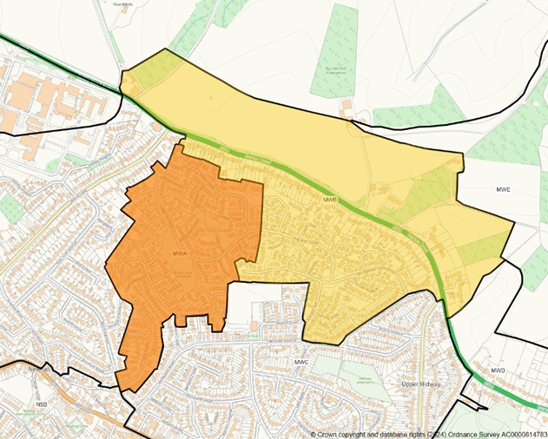

Newhall and Stanton | Newhall | NSA | To even off the number of electors in Polling Districts by adjusting the boundaries between NSA/NSB (Fig.6). | 41 | Newhall Scout Hall, Higgins Road, DE11 0JY | No Change
 | Newhall | NSB | To even off the number of electors in Polling Districts by adjusting the boundaries between NSA/NSB and NSB/NSC (Fig.6). | 42 | Royal Oak Boxing Club, Off Orchard Street, Newhall, DE11 0JS | Polling Place to be deleted and NSB electors to use Polling Place at Newhall Scout Hall.
 | Newhall | NSC | To even off the number of electors in Polling Districts by adjusting the boundaries between NSB/NSC (Fig.6). | 43 | Newhall Centre, Meadow Lane, DE11 0UW | New Polling Place at The Hawfields, St Johns Drive, Newhall, DE11 0SR
 |  |  |  | 44 | Newhall Centre, Meadow Lane, DE11 0UW | New Polling Place at The Hawfields, St Johns  Drive, Newhall, DE11 0SR. 0.7 miles walk from Newhall Centre.
 | Newhall | NSD | No Change | 45 | The Hawfields, St. John`s Drive, Newhall, DE11 0SR | No Change
 | Newhall | NSE | No Change | 46 | Stanton Village Hall, Woodland Road, DE15 9TJ | No Change

Figure 6 - Polling District NSB, the area shaded yellow, to include the area shaded orange (part of Polling District NSA) and the area shaded green (part of Polling District NSC).
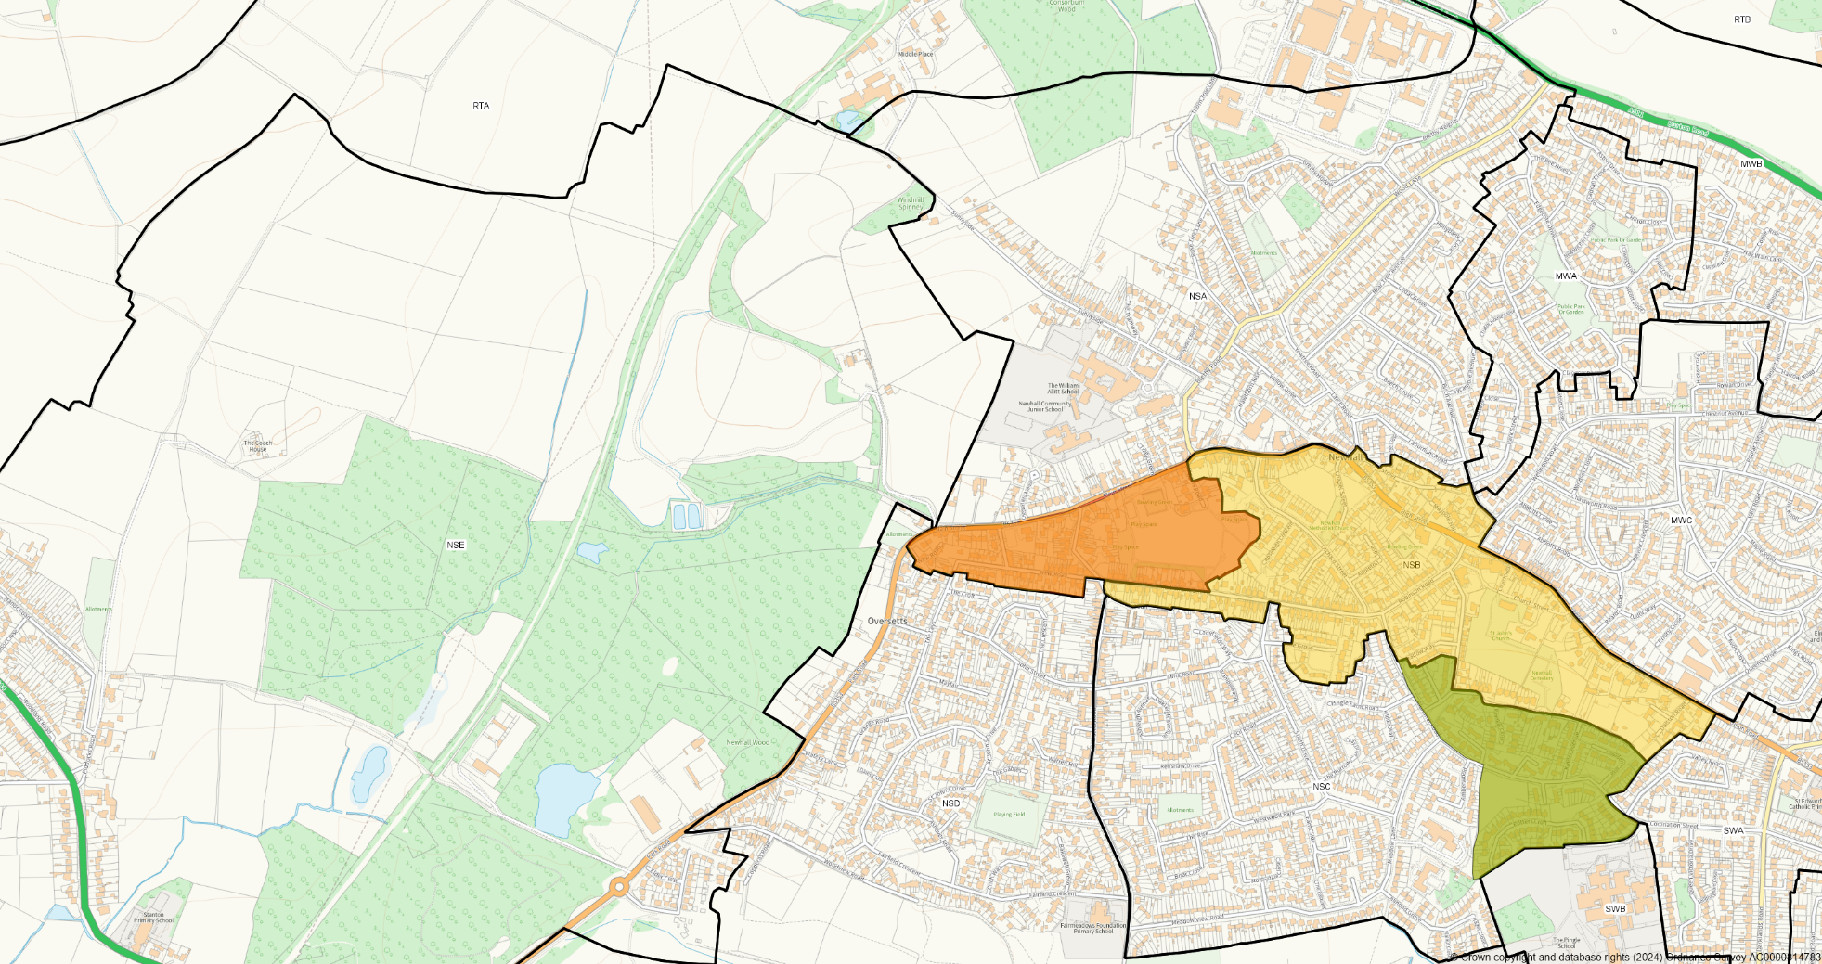

Repton | Bretby | RTA | Merge RTA/RTB (Fig.7). | 47 | St Wystan`s Church, The Green, Bretby, DE15 0RE | No Change
 | Bretby | RTB | Merge RTA/RTB (Fig.7).  . | 47 | St Wystan`s Church, The Green, Bretby, DE15 0RE | No Change
 | Calke | RTC | No Change | 48 | Ticknall Village Hall, Ingleby Lane, DE73 7JW | No Change
 | Foremark | RTD | No Change | 49 | Milton Village Hall, Main Street, DE65 6EH | No Change
 | Ingleby | RTE | No Change | 49 | Milton Village Hall, Main Street, DE65 6EH | No Change
 | Newton Solney | RTF | No Change | 50 | Newton Solney Village Hall, Repton Road, DE15 0SG | No Change
 | Repton | RTG | No Change | 51 | Repton Village Hall, Askew Grove, DE65 7LA | No Change
 |  |  |  | 52 | Repton Village Hall, Askew Grove, DE65 7LA | No Change
 | Repton parish (Milton) | RTH | No change.  For the County Council Elections, we will have separate ballot boxes for the different County Divisions. | 49 | Milton Village Hall, Main Street, DE65 6EH | No Change
 | Smibsy | RTI | No Change | 53 | Smisby Village Hall, Main Street, LE65 2TY | No Change
 | Ticknall | RTJ | Rename RTB. | 48 | Ticknall Village Hall, Ingleby Lane, DE73 7JW | No Change

Figure 7 - Polling District RTA, shaded orange, to merge with Polling District RTB, as shaded yellow, to create a single combined Polling District titled RTA
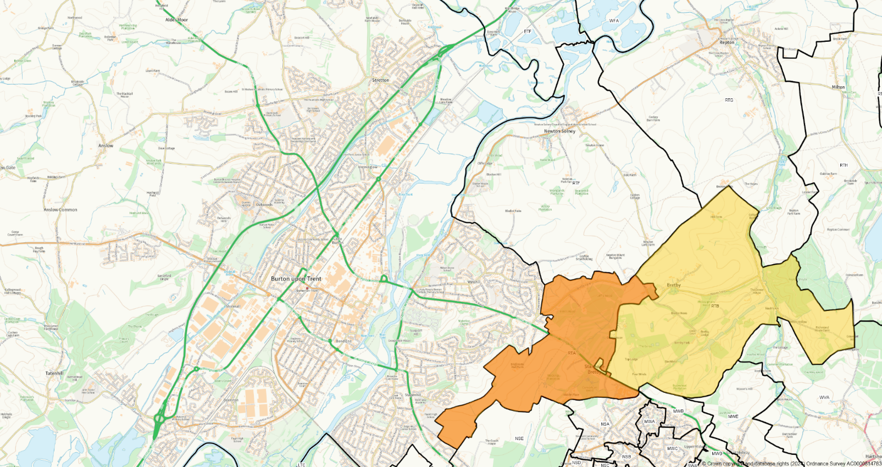

Seales | Catton | SLA | No Change | 54 | Walton-on-Trent Village Hall, Main Street, DE12 8LZ | No Change
 | Coton-in-the-Elms | SLB | No Change | 55 | Coton in the Elms Community Centre, Elms Road, DE12 8HD | No Change
 | Lullington | SLC | No Change | 56 | Lullington Village Hall, Main Street, DE12 8EG | No Change
 | Netherseal | SLD | No Change | 57 | Netherseal Village Hall, Main Street, DE12 8BZ | No Change
 | Overseal | SLE | No Change | 58 | Overseal Village Hall, Woodville Road, DE12 6LU | No Change
 |  |  |  | 59 | Overseal Village Hall, Woodville Road, DE12 6LU | No Change
 | Walton-on-Trent | SLF | No Change | 54 | Walton-on-Trent Village Hall, Main Street, DE12 8LZ | No Change

Stenson | Stenson Fields | STA | No Change | 60 | Stenson Fields Community Centre, Chartley Road, DE24 3BT | No Change
 |  |  |  | 61 | Stenson Fields Community Centre, Chartley Road, DE24 3BT | No Change
 | Stenson Fields (West) | STB1 | STB1 to be renamed STB. | 78 | Stenson Fields Community Centre, Chartley Road, DE24 3BT | No Change
 | Twyford & Stenson | STB2 | STB2 to be renamed STC. | 78 | Stenson Fields Community Centre, Chartley Road, DE24 3BT | No Change

Swadlincote | Swadlincote | SWA | Divide into 2 Polling Districts along the County Division boundary (Fig.8).  Yellow shaded area as shown in Fig.8 be titled SWF. Unshaded area remains as SWA.  Electors will continue to vote at Polling Place 62, but for county elections we will use separate ballot boxes for the different County Divisions. | 62 | Civic Offices, Civic Way, Swadlincote, DE11 0AH | No Change
 | Swadlincote | SWB | No Change | 63 | Emmanuel Church Hall, Church Street, Swadlincote, DE11 8LF | No Change
 | Swadlincote | SWC | Adjust SWC/SWD boundary to align with new County Divisions (Fig.9) | 64 | Town Hall, The Delph, Swadlincote, DE11 0AG | No Change
 | Swadlincote | SWD | Adjust SWC/SWD boundary to align with new County Divisions (Fig.9)  . | 65 | Pennine Way Junior Academy, Pennine Way, Swadlincote, DE11 9EY | No Change
 | Swadlincote | SWE | No Change | 66 | Emmanuel Church Hall, Church Street, Swadlincote, DE11 8LF | No Change
 | Swadlincote | SWF | Incorporate Polling District SWF (shaded blue) in Fig.9 into Polling District SWC. | 64 | Town Hall, The Delph, Swadlincote, DE11 0AG | No Change

Figure 8 - Proposed that a new Polling District is created and titled SWF, shaded yellow, from part of SWA.
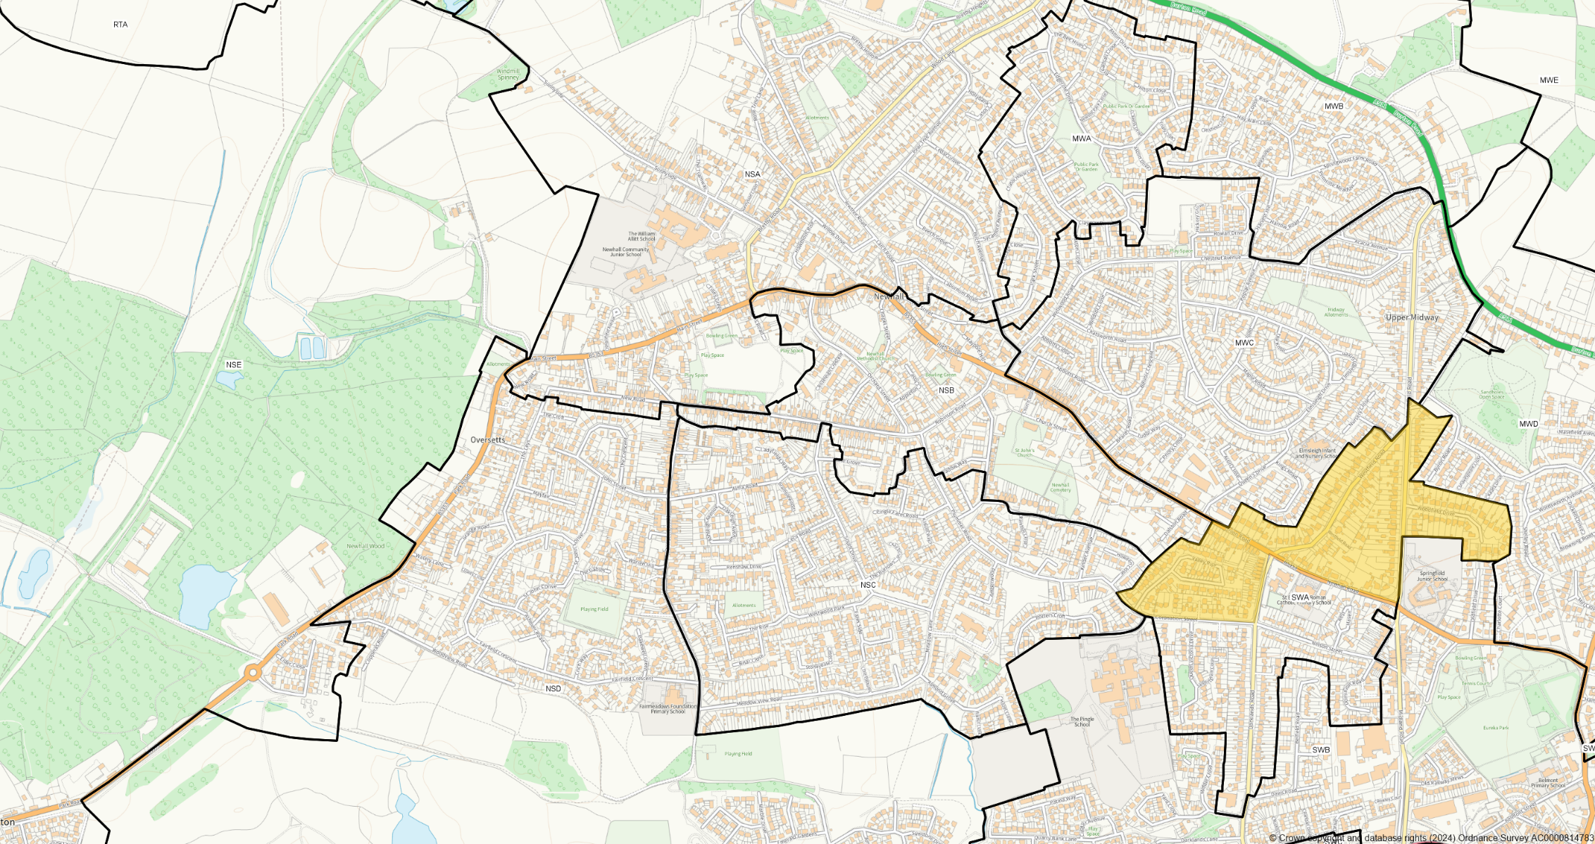
Figure 9- Polling District SWC, the area shaded yellow, expands to include the area shown in orange, part of SWD, and Polling District SWF, shaded in blue, to be incorporated into Polling District SWC (shaded yellow)
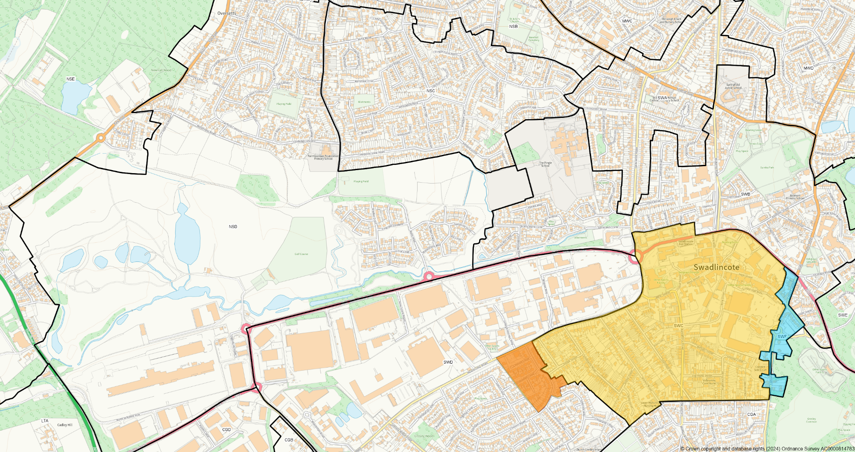

Willington and Findern | Willington | WFA | No Change | 67 | Willington Village Hall, Twyford Road, Willington, DE65 6DE | No Change
 |  |  |  | 68 | Willington Village Hall, Twyford Road, Willington, DE65 6DE | No Change
 | Findern (North) | WFB1 | WFB1 to be renamed WFB. | 77 | Highfields Spencer Academy, Tutbury Avenue, DE23 3AT | No Change
 | Findern | WFB2 | WFB2 to be renamed WFC. | 69 | Findern Village Hall, Castle Hill, DE65 6AL | No Change

Woodville | Hartshorne | WVA | No Change | 70 | Community Room, Kendricks Close, Hartshorne, DE11 7AG | No Change
 | Hartshorne | WVB | No Change | 71 | Goseley Community Centre, Hartshill Road, DE11 7HN | No Change
 | Woodville | WVC | Divide Polling District WVC along the county boundary (Fig.10). To create a reduced Polling District WVC and a new Polling District WVF.  WVC will be allocated to polling station 72 and the new Woodville Polling District (WVF) will be allocated to polling station 73. | 72 | Woodville Youth & Community Centre, Moira Road, DE11 8DQ | No Change
 |  |  |  | 73 | Woodville Youth & Community Centre, Moira Road, DE11 8DQ | No Change
 | Woodville | WVD | Adjust WVC/WVD boundary to align with new County Divisions and the Woodville Parish Council warding (Fig.10). | 74 | Woodville Snooker and Social Club, High Street, DE11 7EH | No Change
 |  |  |  | 75 | Woodville Snooker and Social Club, High Street, DE11 7EH | No Change
 | Woodville | WVE | No Change | 76 | Woodville Scout Hall, Rose Hill, DE11 8DF | No Change
Figure.10 - Part of Polling District WVC as shaded blue, to be incorporated in Polling District WVD and the remainder of Polling District WVC to be divided into two Polling Districts. The area shaded yellow to be titled WVC and the area shaded orange to be titled WVF. 