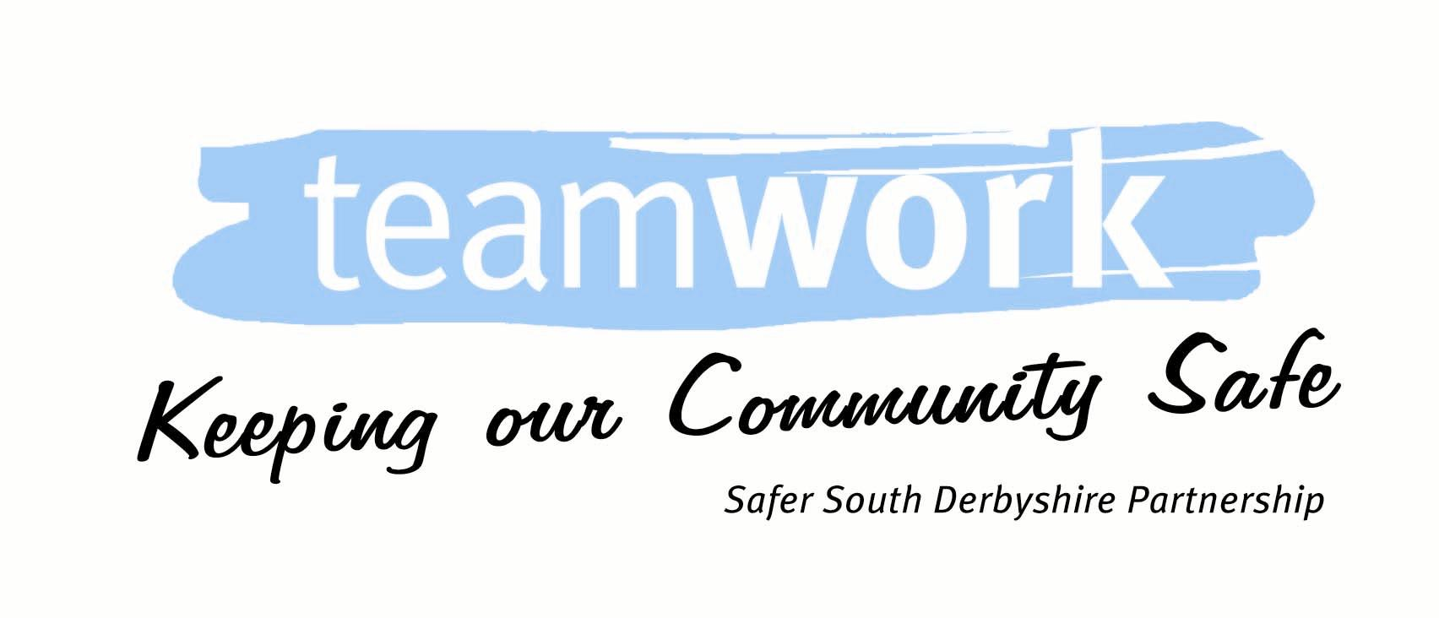

SAFER & STRONGER NEIGHBOURHOODS’ FUND 2023-24

APPLICANTS GUIDANCE

1. About the Safer & Stronger Neighbourhoods funding

  - The Safer and Stronger Neighbourhood Funding stream is available to local community groups, parish councils, clubs & associations and not for profit organisations. The aim is to give local people the opportunity to initiate and develop projects to make their community feel safer and to enhance the local community.

  - The South Derbyshire Community Safety Partnership recognises that local people are crucial to the development of Safer and Stronger Neighbourhoods, and we are looking to encourage worthwhile projects which will help reduce crime and the fear of crime, combat anti-social behaviour and encourage people to be active in their local communities through setting up and delivering new community groups, sessions, clubs and associations.

  - The Safer and Stronger Neighbourhoods Fund for the whole of the South Derbyshire District is £24,000. This is divided into £4,000 per Safer Neighbourhood area. Project applications will need to show what they will do and how they will impact on crime, fear of crime, anti-social behaviour or community development in the local community.

2. How much can I apply for?

2.2 The maximum that can be applied for is £2,500, and applications will be accepted at any time. Applications which have met with the set criteria will be submitted to the next relevant Area Forum for approval.

2.3 Any funding remaining after the third quarter meetings will go into the ‘Big Pot’ which is open for bids from any area. The applications approved through the Big Pot will be announced at the next public forum. Applications submitted to the Big Pot will be approved by the Chair of the South Derbyshire Community Safety Partnership.

3. What must my project show?

3.1 To be eligible, your project must be able to show that it goes some way towards addressing at least one or more of the priority areas identified by the Community Safety Partnership.

3.2 The priorities which your project must impact on are:
1. Anti-social behaviour (disorder and criminal damage)
2. Acquisitive crime (burglary, theft) and offender management
3. Domestic abuse and sexual violence
4. Creating stronger communities
5. Protecting those most at risk
6. Alcohol-related harm and substance misuse
7.Creating Safer Spaces

Copies of the Partnership Plan are available at: https://www.southderbyshire.gov.uk/our-services/crime-and-community-safety/the-safer-south-derbyshire-partnership

or via email from:community.safety@southderbyshire.gov.uk

- Matched Funding:

4.1 If you are applying for more than £500 you will need to obtain some matched funding from an alternative source. The level of matched funding required will depend upon the value of grant (see table below).

Amount of grant | Minimum matched funding requirement
Less than £500 | Volunteer time only
£501 - £1,500 | 25% of the value of the project
£1,500 - £2,500 | 50% of the value of the project

4.2 If you need any help obtaining match funding for your project please contact Sally Hemsley, Community Partnership Officer, on 07799 049615 or by email at sally.hemsley@southderbyshire.gov.uk

- Projects

5.1 Your project application will need to show:
- That you have consulted and have the support from the local community and where applicable sought expert advice e.g: liaise with Police Officers and South Derbyshire Community Safety Partnership
- How and why the project will make a difference in your local community.
- Who will be delivering the project (i.e. name of organisation, community group, parish council etc).
- What other resources will be needed to deliver the project (including other external funding).
- How you will know if your project is a success. How will success be measured?
- How any ongoing costs will be met?
- It’s realistic and will it provide value for money.

5.2 A few examples of the types of project that could be eligible are outlined below:

EXAMPLE OF PROJECTS | WHICH POSSIBLE PRIORITIES COULD THIS KIND OF PROJECT MEET
Providing activities to engage with young people. Setting up youth groups. Purchasing equipment to assist with the development of youth groups. Educating young people on crime and disorder issues | Anti-social behaviour, creating stronger communities, protecting those most at risk
Support development of new community groups and projects which will engage, strengthen and/ or protect the local community  Provide advice and reassurance to local residents on crime and disorder issues. | Creating stronger communities, ASB, Protecting those most at risk,  Acquisitive crime, protecting those most at risk
Installation of target hardening measures to secure community buildings, including fencing/ alarm systems/ CCTV  Development of projects that will protect and secure the community, particularly children and vulnerable people | ASB, creating stronger communities, acquisitive crime  Protecting those most at risk , alcohol-related harm, ASB, domestic abuse
Designing or supporting local campaigns, or producing material to assist on raising awareness on crime and disorder | ASB, alcohol-related harm, substance misuse, domestic abuse, protecting those most at risk, acquisitive crime

5.3 Please note that these are only a few simple examples. If you are unsure about whether your proposed project is likely to be eligible, please contact the Communities Team at SDDC on 01283 595924 or by email at community.safety@southderbyshire.gov.uk

5.4 We will not fund projects retrospectively.

6 Application procedure

6.1 The application must be made on behalf of a (non-profit) organisation, group or society, and the bank transfer should be made payable to a registered bank account i.e.: school, sports club, parish council, youth club, residents association etc. If an applicant does not have a registered bank account other arrangements may be possible for another organisation to hold the funding. For further information please contact Sally Hemsley, Community Partnership Officer, on 07799 049615 or by email at sally.hemsley@southderbyshire.gov.uk

6.2 All completed applications will be submitted to the Communities Team at SDDC c/o South Derbyshire District Council, Civic Way, Swadlincote, Derbyshire DE11 0AH or by email at: community.safety@southderbyshire.gov.uk

6.3 On receipt of a completed application form the Communities Team at SDDC will check to ensure that the project meets the required partnership criteria, and that the application provides suitable information.

6.4 Once the application has been checked, the applicant will be advised of the outcome within seven days. There will be two possible outcomes:

- The applicant will be advised that the project and the application meets the required partnership criteria and that the application will be presented to the next round of Area Forum meetings for approval.

- The application did not meet the required partnership criteria. If this occurs, feedback will be provided on why the application did not meet the criteria and assistance will be offered to improve the application where applicable.

6.5 If the application meets the set partnership criteria it will be presented to the next Area Forum meeting for approval. Applicants are encouraged to attend the meeting wherever possible to answer any questions, but it is not mandatory.

6.6 In exceptional circumstances and when a need can be clearly demonstrated (i.e.; to prevent further crime and ASB occurring), applications can be approved by the Chair of the Area Forum and the Chair of the South Derbyshire Community Safety Partnership on request.

6.7 If two or more applications are received at the same time that will use more than the total of the available allocation, the applications will be checked against the partnership criteria as per normal and the successful ones will be presented at the next meeting. The partnership will recommend a split of the funding based on the proposed project, the applications and the set scoring criteria and the recommendation will be presented for the meeting to approve.

7 Timescales

7.1 Once the application has been approved the applicant will be issued an offer letter containing conditions of grant and an acceptance slip. This should be signed and returned to the Communities Team at SDDC within 30 days of the date of the offer letter.

7.2 Once the Communities Team at SDDC receives the signed acceptance slip, the bank transfer for the full funding amount will be available for the applicant to request when the project is ready to be completed. The payment will not be issued automatically.

7.3 All projects where the grant is offered before December 31st should be complete by March 31st, unless a deadline extension has been approved by the partnership. All accompanying receipts and invoices should also be submitted by this date.

7.4 Projects funded via the ‘Big Pot’ will have until the end of March the following year to complete the project.

7.5 Applications can be submitted at any time, however in order to receive funding via the big pot, applications should be submitted by the end of February in order to leave enough time to be processed by year end.

8 Condition of Grants

8.1 The following conditions of grant will be sent out with the offer letter. The applicant must sign up to agree to these conditions before the funding will be released.

- You should provide three competitive quotations for each item of capital expenditure you intend to purchase. Capital items are generally buildings or equipment (i.e.: fencing, CCTV, security works, lighting, play equipment etc). If you are unable to provide three competitive quotations an explanation should be given as to why this is not possible

(ii) The partnership will release the funding on request from the project lead. Funding should not be requested until the project is ready to be delivered.

  - This project must be completed, and copies of receipted invoices provided to the partnership no later than March 31st unless an extension is agreed with the Communities Team at SDDC.

  - The Communities Team at SDDC reserves the right to publicise its involvement with this crime prevention project.

- The expenditure must relate to the purchase and installation of materials, or the hire of services in relation to the original application.

- Communities Team at SDDC has the right to require information and assistance from you (the grant beneficiary) as to the satisfaction of any of the grant conditions - such information as is required to be provided in writing within 10 working days of such request.

- You obtain planning permission to install any proposed buildings or security measures where applicable prior to the payment of any grant. If you are unsure, please contact the SDDC Planning Dept. on 01283 228706 or by email at planning@southderbyshire.gov.uk .

- An evaluation report will be produced on completion of the project, which will be submitted to the Area Forum.

- If your application is for funding towards a CCTV system it is your responsibility to ensure that you are compliant with the Data Protection Act 1998. This includes ensuring there is adequate signage in place, you register the system with the Information Commissioner’s Office (ICO) (if necessary), and if required pay the appropriate Data Protection Fee.

This can be done online https://ico.org.uk/for-organisations/data-protection-fee . You can also contact the ICO helpline for advice on 0303 123 1113. On request we can also provide a small user CCTV check list to assist you.

